James Deas
UWS | Paisley Campus
Implementing Google’s Organic Local SEO Strategies for SMEs
Research Methods in Computing - COMP09092

Abstract
In today's digital age, small and medium-sized enterprises (SMEs) face fierce competition for online visibility. Google's search engine algorithms prioritize local search results, with over 1.5 billion users per month (ZipDo, 2023), it is imperative for SMEs to optimize their online presence according to Google's guidelines for organic local SEO. This research proposal aims to explore the implementation of Google's organic local SEO strategies for SMEs.

Through an in-depth analysis of Google's guidelines, case studies of successful implementations, and expert interviews, this research seeks to develop practical recommendations for SMEs to enhance their online visibility, attract local customers, and compete effectively in the digital marketplace.

The proposed research outlines a comprehensive approach to investigating the implementation of Google's organic local SEO strategies for SMEs. While the research methods described are ambitious, it's essential to note that this proposal serves as a blueprint for the intended study. In practice, the actual implementation of these research methods may be subject to feasibility constraints, resource availability, and ethical considerations. Therefore, the outlined research methods represent an idealized framework for conducting the study, acknowledging that adjustments and adaptations may be necessary during the actual research process.

1 Introduction

1.1 Aims and Objectives

1.1.1 Aims
To delve into the practical implementation of Google's organic local SEO strategies within SMEs, scrutinizing its effectiveness in enhancing online visibility and attracting local clientele.

1.1.2 Objectives

- To analyse Google's guidelines for organic local SEO, discerning key principles and identifying best practices tailored to the unique needs and constraints of SMEs.

- To identify and scrutinize case studies of SMEs that have successfully implemented Google's organic local SEO strategies, extracting insights, lessons learned, and noteworthy strategies for emulation.

- To develop comprehensive and pragmatic recommendations for SMEs based on the findings from the analysis of Google's guidelines and the examination of case studies, providing actionable guidance for enhancing online visibility and competitiveness in the digital marketplace.

1.2 Justification
In today's rapidly evolving digital landscape, SMEs must prioritize securing organic visibility on search engines like Google to effectively target local customers and uphold competitiveness. With Google's dominant market position boasting a staggering 93.51% share of UK internet users (Statista, 2024) and a monthly global user base of 1.5 billion (ZipDo, 2023), optimizing for search engine visibility becomes paramount for sustained growth and brand recognition.

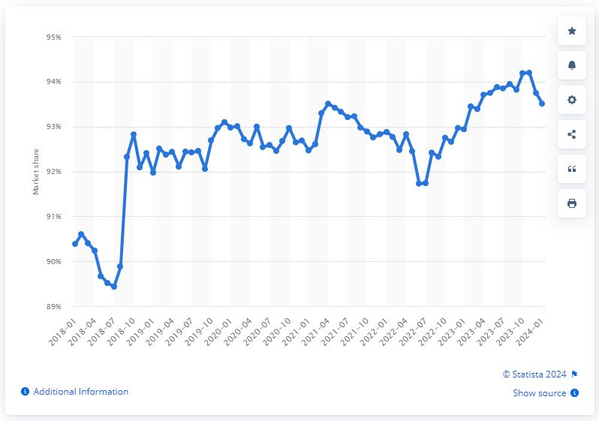

(Image Source: Statista, 2024)

By adhering to Google's organic local SEO strategies, SMEs can substantially enhance their visibility in local search results, thereby effectively reaching their target audience. This research endeavour is poised to equip SMEs with invaluable insights and actionable recommendations to optimize their online presence across Google's platforms.

2 Literature and Technical Review

2.1 Understanding Google’s Organic Local SEO

SEO, short for Search Engine Optimization, is a set of techniques used to improve a website's visibility on search engines like Google. By optimizing various aspects of a website, such as its content, structure, and links, SEO aims to make it more likely to appear higher up in search results for relevant queries.

Organic SEO, also referred to as natural SEO, encompasses strategies aimed at enhancing a website's visibility in search engine results pages (SERPs) through unpaid methods. It involves optimizing various elements of a website, such as content, keywords, and backlinks, to rank higher in search results organically. WebFX states that organic SEO involves tactics such as keyword research, link building, content creation and optimising page load times (WebFX, 2024). Unlike paid advertising, which involves paying for placement, organic SEO focuses on improving a website's relevance and authority to attract organic traffic.

Local SEO, on the other hand, is a digital marketing approach tailored to enhance a business's visibility in local search results. Unlike traditional SEO, which targets a global audience, local SEO aims to connect businesses with nearby consumers. MailChimp argues that any business that has a physical location or serves a geographic area can benefit from local SEO (MailChimp, 2024). It involves optimizing a business's online presence for location-based searches, such as those conducted on Google Maps or with location-specific keywords.

Google's Organic Local SEO Strategies are geared towards elevating businesses' visibility in local search results, making them more discoverable to nearby consumers. These strategies revolve around three key factors: relevance, proximity, and prominence.

Relevance refers to how well a local business's profile matches a user's search query. Google evaluates factors such as keywords, content, and website optimization to determine relevance. Proximity considers the distance between the user's location and the businesses listed in the search results. Google prioritizes businesses that are geographically closer to the user, especially for location-based queries. Prominence refers to the overall popularity and credibility of a business. Factors such as online reviews, citations, and backlinks contribute to a business's prominence in local search rankings.

For small and medium-sized enterprises (SMEs) that rely on local customers, organic local SEO is invaluable. It helps SMEs increase their online visibility within their target market, attract relevant leads, and compete effectively with larger competitors in their area. By aligning with Google's local SEO strategies and optimizing their online presence, SMEs can enhance their chances of being found by local customers and driving growth in their local market.

2.2 Google Business Profile
Google Business Profile (GBP), formerly known as Google My Business (GMB), stands as the linchpin of Google's Local Organic SEO strategy, offering businesses a dedicated platform to manage their online presence across Google's ecosystem, including Google Maps. GBP provides essential information to potential customers, such as business hours, contact details, address, website URL, and more.

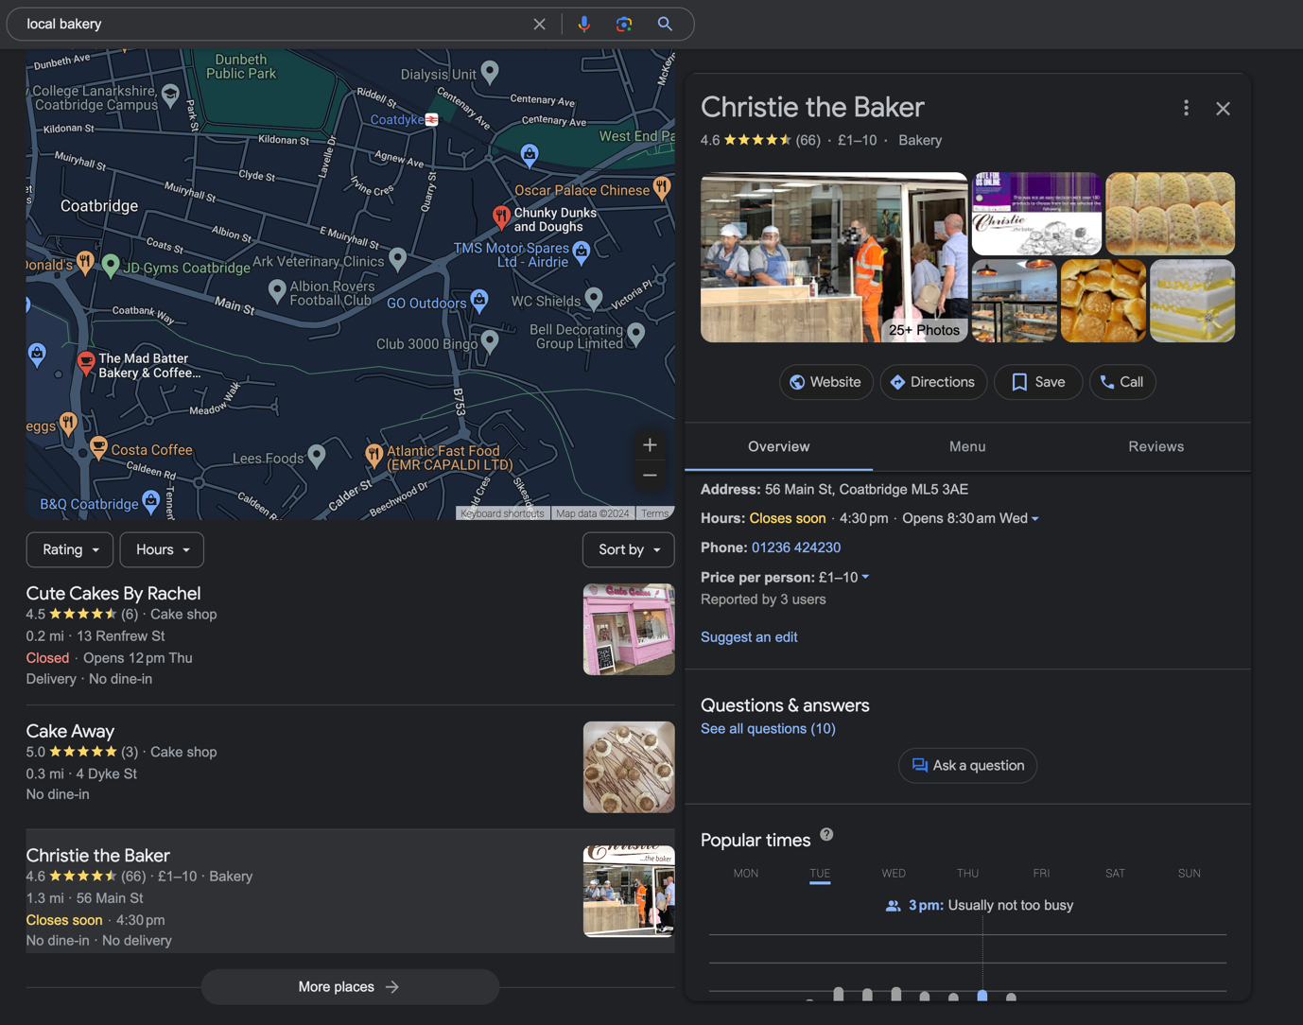

(Image Source: Screen captures - Google.com)
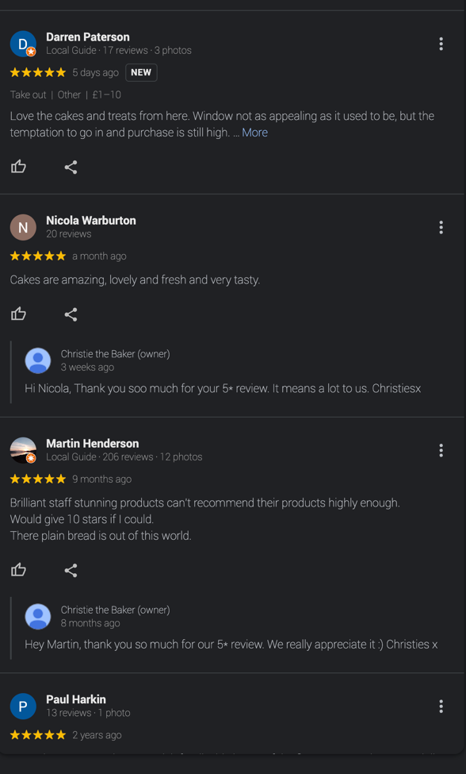
Optimizing a Google Business Profile is crucial for enhancing your visibility in local search results and building credibility with potential customers, mainly because according to BrightLocal, without a local business listing, you can’t rank in the Local Pack, or appear on Google Maps (BrightLocal, 2024). Creating and maintaining a GBP involves providing accurate and up-to-date business information, encouraging positive customer reviews, and engaging with user-generated content.

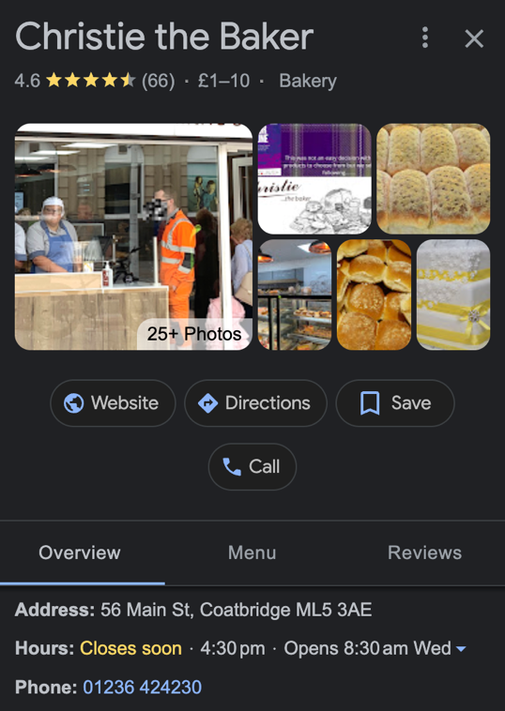
To optimize a GBP profile, ensure that all business information, including name, address, phone number (NAP), and business categories, is accurate and consistent across all online platforms and directories.

Consistency in business information is key to improving search rankings and user experience. Goup argues that the more you can solidify your identity the better. Through listing your NAP details consistently, you demonstrate your presence in a certain area, and most importantly, your right to rank for location-based searches performed there (Goup, 2023).

Encouraging positive customer reviews is another essential aspect of GBP optimization. Positive reviews not only contribute to a business's reputation but also influence local search rankings. NiceJob states that the more five-star reviews your product or service gets, the more they attract potential customers. When people keep visiting your website, search engines start to identify you as an authoritative site (NiceJob, 2024). It is then, in the best interest of businesses to encourage satisfied customers to leave reviews on their GBP profile and respond promptly and courteously to all customer feedback, whether positive or negative.

Engaging with user-generated content on your GBP profile, such as photos, videos, and customer questions, further enhances your online presence and fosters greater engagement with potential customers. Regularly update your GBP profile with high-quality images and videos showcasing your products, services, and facilities.

2.3 Organic Local SEO Success Stories
In this section, I present a selection of successful case studies that exemplify the implementation of Google's Organic Local SEO strategies by Small and Medium Enterprises (SMEs). These case studies were chosen based on their alignment with the research focus on improving local search visibility and online presence for SMEs.

2.3.1 Levy & Co: Increase their bookings by 70% using Google Business Profile

Levy & Co, a men's barbershop located in Kensal Green, Northwest London, is distinguished by its founder, Syreeta Levy, a black, gay woman. Since its establishment, Levy & Co has garnered attention for its unique identity, offering not only haircuts but also a space for counselling—a testament to Syreeta's personal connections with her customers. Inspired by her late brother, Syreeta embarked on the journey of entrepreneurship, naming the shop in his honour. Recognizing the importance of online visibility and efficient booking systems, Syreeta turned to Google Business Profile (GBP) to establish Levy & Co's presence and streamline operations.

GBP serves as a vital tool for enhancing local search visibility and attracting customers to Levy & Co. By leveraging attributes such as 'Women-Led' and 'LGBTQ+' on the profile, Syreeta strategically appeals to her target audience, emphasizing the shop's inclusive ethos. Additionally, the inclusion of photos showcasing the shop's unique character enhances its visibility and intrigue, drawing potential customers to explore further.

Syreeta's implementation of GBP involved a meticulous approach to profile setup and management. Attributes highlighting Levy & Co's distinctive features were strategically selected to resonate with the target clientele, while the addition of photos provided a visual representation of the shop's ambiance. Amidst the challenges posed by the COVID-19 pandemic, Syreeta recognized the importance of an efficient online booking system. Integrating GBP with the shop's booking page enabled seamless appointment management, ensuring compliance with safety regulations while maximizing customer convenience.

The adoption of GBP yielded significant results for Levy & Co, particularly amidst the pandemic-induced lockdown. The shop experienced a substantial increase in website traffic, with mobile traffic surging by over 400% compared to the previous year. This surge translated into a remarkable 70% increase in bookings, all facilitated through the website. The visibility provided by GBP, coupled with Levy & Co's unique attributes, attracted a diverse clientele, contributing to the shop's success and reputation. Positive reviews further solidified the shop's standing within the community, with over fifty 5-star reviews praising not only the quality of haircuts but also the overall experience at Levy & Co.

Syreeta's journey with Levy & Co offers valuable insights for SMEs, particularly in traditionally male-dominated industries. Her experience underscores the significance of leveraging digital tools like Google My Business to enhance visibility, attract customers, and drive business growth. Moreover, her emphasis on inclusivity and personal connection highlights the importance of authenticity and community engagement in establishing a loyal customer base. Syreeta's advice to other women entrepreneurs underscores the importance of self-belief and perseverance, encouraging aspiring entrepreneurs to pursue their aspirations with confidence and determination.

In summary, the case of Levy & Co exemplifies the transformative impact of leveraging Google Business Profile for SMEs. The tangible benefits of enhanced visibility, increased bookings, and strengthened community engagement underscore the importance of investigating the effectiveness of Google's organic local SEO strategies for SMEs. This research proposal seeks to delve deeper into such success stories, analysing the strategies and practices employed by SMEs like Levy & Co to develop practical recommendations for enhancing online visibility and competitiveness in the digital marketplace.

2.3.2 She Moves Removals: Boosts Local Profile with Google Business Profile

Founded in 2017 by Donna Evans, She Moves is a women-led removal company based in South Wales, offering an alternative to traditional 'man with van' services. Donna's entrepreneurial journey began with her employment in a logistics role, where she started offering simple removal services on her days off. Inspired by her hands-on approach and the desire to work in a trade, Donna founded She Moves to provide professional and reliable removal services. Despite facing initial challenges in establishing credibility, Donna recognized the importance of building trust with customers and sought to leverage GBP to enhance the company's online presence and reputation.

Utilizing GBP, She Moves strategically showcases its unique selling proposition as a female-only company, emphasizing the 'Women-led' icon on the profile. This deliberate branding differentiates She Moves from competitors and appeals to customers seeking a more delicate approach to their moves. Moreover, Donna leverages customer reviews on Google My Business to highlight She Moves' professionalism and positive reputation, effectively translating local sentiment into online credibility and lead conversion.

Donna actively manages She Moves' GBP to maintain visibility and promote the company's reputation. By curating positive customer experiences and emphasizing professionalism, Donna ensures that the profile accurately reflects She Moves' values and unique selling points. Leveraging customer reviews and local sentiment, Donna effectively communicates She Moves' commitment to excellence, driving lead generation and business growth.

Since its inception, She Moves has experienced significant growth, expanding from a one-person operation to a team of eight employees and four vans. The company's GBP boasts numerous 5-star reviews, serving as a testament to its professionalism and reliability. This visibility has contributed to a substantial increase in profile views and lead generation, with a significant portion of leads originating directly from Google Search. The growing fleet of branded vans further enhances brand recognition and drives inquiries, positioning She Moves as a trusted choice for removal services in the region.

Donna's journey with She Moves underscores the importance of leveraging digital platforms like GBP to establish credibility, enhance visibility, and drive business growth. Her proactive approach to managing the company's online presence demonstrates the value of authenticity and reputation in attracting and retaining customers. Moving forward, She Moves aims to capitalize on its local establishment and further leverage digital platforms for continued growth and success.

2.4 Search Engine Optimization Tools

In the world of digital marketing and search engine optimization (SEO), the landscape is replete with various tools designed to streamline processes, optimize strategies, and measure outcomes. These tools play a crucial role in assisting businesses, including small and medium-sized enterprises (SMEs), in improving their online visibility and attracting relevant traffic. In this section, I explore some of the key SEO tools commonly used by SMEs to enhance their Organic Local SEO efforts.

2.4.1 Google Keyword Planner

Google Keyword Planner stands as a cornerstone tool for keyword research, a fundamental aspect of SEO strategy development. This tool enables SMEs to identify relevant keywords and search terms with high search volume and low competition, aiding in the optimization of website content to align with user search intent. By leveraging Google Keyword Planner, SMEs can gain valuable insights into popular search queries within their target market, thereby refining their content strategy to improve organic search visibility.

2.4.2 SEMrush

Although not a Google software, SEMrush is a comprehensive SEO toolkit that offers a wide range of functionalities to help SMEs analyse their online presence, conduct competitor research, and optimize their digital marketing efforts. With features such as keyword research, backlink analysis, site audit, and position tracking, SEMrush provides SMEs with actionable insights and data-driven recommendations to improve their organic search performance. Moreover, SEMrush's local SEO toolkit offers specific tools and features tailored to enhance businesses' visibility in local search results, making it an asset for SMEs targeting local customers.

2.4.3 Moz Local

Also, essential however not a Google software, Moz Local is a specialized tool designed to help SMEs manage and optimize their online listings and local citations. With Moz Local, businesses can ensure the accuracy and consistency of their business information across various online directories, review sites, and mapping services, thereby improving their visibility in local search results. Additionally, Moz Local provides insights into the health of a business's online presence, identifies opportunities for improvement, and tracks performance metrics to measure the effectiveness of local SEO efforts.

2.4.4 Google Analytics

Google Analytics remains a staple tool for website performance analysis and measurement. By tracking key metrics such as website traffic, user behaviour, and conversion rates, SMEs can gain valuable insights into the effectiveness of their Organic Local SEO strategies. Google Analytics enables businesses to identify trends, track user engagement, and measure the impact of SEO efforts on website traffic and conversions. With customizable reports and dashboards, SMEs can tailor their analytics data to suit their specific business objectives and KPIs, facilitating informed decision-making and strategy refinement.

2.4.5 Google Search Console

Google Search Console offers a suite of tools and reports to help SMEs monitor and optimize their website's presence in Google search results. From indexing status and crawl errors to search performance and mobile usability, Google Search Console provides valuable insights into how Google perceives and ranks a website. SMEs can use this data to identify and address technical issues, optimize their website for mobile users, and improve their overall visibility and performance in Google search results. Additionally, Google Search Console offers tools for managing and submitting sitemaps, monitoring backlinks, and diagnosing search-related issues, making it an indispensable tool for SMEs aiming to enhance their organic search presence.

In conclusion, incorporating SEO tools into their digital marketing arsenal empowers SMEs to optimize their online presence, improve their visibility in local search results, and attract relevant traffic to their websites. From keyword research and competitor analysis to performance tracking and website optimization, these tools offer invaluable insights and functionalities to support SMEs in their organic local SEO efforts. By leveraging the capabilities of SEO tools effectively, SMEs can enhance their competitiveness in the digital marketplace and drive sustainable growth and success.

3 Research Methodology and Development Approach

3.1 Research Design
For this study, a mixed-methods approach will be employed to gather comprehensive data and insights into the implementation of Google's Organic Local SEO strategies for SMEs. This approach integrates qualitative and quantitative research methods to provide a multifaceted understanding of the research topic.

3.2 Ethical Considerations
Ethical considerations will be paramount throughout the research process. Informed consent will be obtained from all participants, and their confidentiality and privacy will be protected. Data will be handled and stored securely, and any potential conflicts of interest will be disclosed and managed appropriately. Additionally, transparency and honesty will be maintained in reporting research findings and recommendations to ensure the integrity of the research process.

3.3 Qualitative Research Methods
- Expert Interviews: In-depth interviews will be conducted with digital marketing experts, SEO professionals, and SME owners who have experience in implementing Google's Organic Local SEO strategies. These interviews will provide valuable insights, practical advice, and real-world examples of successful implementations.

- Case Studies: Detailed case studies of SMEs that have effectively utilized Google's organic local SEO strategies will be analysed. These case studies will offer insights into the challenges faced, strategies employed, and outcomes achieved by SMEs in improving their online visibility and attracting local customers.

3.4 Quantitative Research Methods
- Surveys: A structured survey will be administered to SMEs to gather quantitative data on their awareness, usage, and perceived effectiveness of Google's Organic Local SEO strategies. The survey will include questions related to their SEO practices, challenges faced, and desired outcomes.

- Website Analytics: Website analytics data, including traffic sources, keyword rankings, and user engagement metrics, will be analysed to assess the impact of implementing Google's Organic Local SEO strategies on SMEs' online visibility and website performance.

3.5 Data Collection
Data will be collected through various methods, including interviews, surveys, and website analytics tools. Interviews will be conducted either in person or via video conferencing, with participants' consent obtained prior to the interviews. Surveys will be distributed electronically to a sample of SMEs, ensuring anonymity and confidentiality of responses. Website analytics data will be collected using tools such as Google Analytics and SEMrush.

3.5 Data Analysis
Qualitative data from expert interviews and case studies will be analysed using thematic analysis techniques to identify recurring themes, patterns, and insights.

Quantitative data from surveys and website analytics will be analysed using statistical methods to identify correlations, trends, and statistical significance.

3.6 Development Approach
After analysing the research findings, the development approach will focus on crafting practical recommendations and guidelines customized for small and medium-sized enterprises (SMEs) to optimize their implementation of Google's Organic Local SEO strategies. These recommendations will be meticulously tailored to address the unique needs, challenges, and opportunities encountered by SMEs in their efforts to enhance online visibility and attract local customers.

The development process will involve the following key steps:

- Identification of Key Insights:
Synthesizing the research findings to identify key insights and trends pertaining to the effectiveness of Google's Organic Local SEO strategies for SMEs. This will involve distilling information from qualitative interviews, case studies, surveys, and website analytics data.

- Understanding SME Needs:
Conducting a comprehensive analysis of the specific needs, challenges, and goals of SMEs in relation to their online presence and local customer acquisition. This step will involve considering factors such as budget constraints, resource limitations, industry dynamics, and competitive landscapes.

- Customized Recommendations:
Crafting tailored recommendations and guidelines that align with the identified insights and address the unique requirements of SMEs.
These recommendations will encompass actionable strategies for optimizing various aspects of Organic Local SEO, including website optimization, content creation, backlink building, citation management, and Google Business Profile (GBP) optimization.

- Practical Implementation Strategies:
Providing SMEs with practical implementation strategies and step-by-step guides to facilitate the execution of recommended SEO tactics. Emphasis will be placed on offering clear instructions, best practices, and resource-efficient approaches that SMEs can easily integrate into their existing workflows.

- Measurement and Monitoring:
Establishing metrics and performance indicators to measure the effectiveness of implemented SEO strategies. Guidance will be provided on leveraging analytics tools to track key performance metrics, monitor progress, and make data-driven adjustments as needed to optimize outcomes.

4 References

Smith, K. (2023) A Comprehensive Guide to Local SEO in 2023, HubSpot [Online]
Available at: https://blog.hubspot.com/marketing/local-seo
[Accessed 22.02.2024]

Saxon, J. (2023) The Benefits of Local SEO: From Visibility to Conversions, SEMrush [Online]
Available at: https://www.semrush.com/local/blog/benefits-of-local-seo/
[Accessed 16.02.2024]

Varno, D. (2022) What is Organic SEO? And Why It’s a Game Changer for Your Business, WebFX [Online]
Available at: WebFx
[Accessed 1.03.2024]

Baye, R. (2015) Search Engine Optimization: What Drives Organic Traffic to Retail Sites, Journal of Economics and Management Strategy [Online]
Available at: https://onlinelibrary.wiley.com/doi/full/10.1111/jems.12141
[Accessed 18.02.2024]

Harnish, B. (2018) What Is Local SEO & Why Local Search Is Important, Maharana Pratap Polytechnic [Online]
Available at: https://www.mppolytechnic.ac.in/mp-staff/notes_upload_photo/CS332LocalizedSEO.pdf
[Accessed 18.02.2024]

Miller, M. (2022) Local SEO For Small Businesses: 7 Top Ways to Gain Visibility, Search Engine Journal [Online]
Available at: https://www.searchenginejournal.com/local-seo-small-business/454910/
[Accessed 16.02.2024]

Vani, A. (2011) Search Engine Optimization for Small and Medium Sized Enterprises, University West of London [Online]
Available at: https://repository.uwl.ac.uk/id/eprint/3173/
[Accessed 22.02.2024]

Silva, C. (2023) Local SEO: What Is It & How to Do It, SEMrush [Online]
Available at: Semrush
[Accessed 22.02.2024]

Google. (2023) How to Improve Your Local Search Ranking on Google, Google Business Profile Help Documents [Online]
Available at: https://support.google.com/business/answer/7091?hl=en-GB#zippy=%2Crelevance%2Cdistance%2Cprominence
[Accessed 16.02.2024]

Google. (2023) Levy & Co Increase their online bookings by 70% using Google My Business, Google Business Profile [Online]
Available at: https://www.google.com/intl/en_uk/business/success-stories/levy-co/
[Accessed 18.02.2024]

Google. (2023) She Moves Removals Boosts Local Profile with Google My Business, Google Business Profile [Online]
Available at: https://www.google.com/intl/en_uk/business/success-stories/she-moves/
[Accessed 18.02.2024]

Pitman, J (2023) BrightLocal’s Simplified Guide to Local Search, BrightLocal [Online]
Available at: https://www.brightlocal.com/learn/the-simplified-guide-to-local-search/
[Accessed 26.02.2024]

Mailchimp. (2024) What is Local SEO, and How Does It Work?, Marketing Library [Online]
Available at: https://mailchimp.com/resources/what-is-local-seo/#:~:text=Start%20harnessing%20SEO&text=This%20way%20your%20business%20can,continues%20to%20grow%20and%20change.
[Accessed 26.02.2024]
GoUp, (2024) Search Engine Optimization, GoUp [Online]
Available at: https://www.goup.co.uk/search-engine-optimisation/
[Accessed 22.02.2024]

Nicholson, M. (2023) How to Do SEO for Small Business: The Complete Guide, NiceJob [Online]
Available at: https://get.nicejob.com/resources/seo-for-small-business [Accessed 26.02.2024]

Statista. (2024) Search Engine Traffic Market Share of Google In United Kingdom from January 2018 to January 2024, Statista [Online]
Available at: https://www.statista.com/statistics/279797/market-share-held-by-google-in-the-united-kingdom-uk/
[Accessed 16.02.2024]

Eser, A. (2023) Essential Google User Statistics in 2024, ZipDo [Online]
Available at: https://zipdo.co/statistics/google-user/#:~:text=According%20to%20recent%20data%2C%20Google,1.5%20billion%20users%20per%20month.
[Accessed 16.02.2024]

